2015 May 6

Seokju Hong, Youngseok Kim

team 2

[회사 주소]

Analysis model

SafeHome Project

Table of Contents

1. Introduction 4

2. Use case diagram 5

2.1. SafeHome bootup/shutdown service 5

2.2. Configuration service 6

2.2.1. Password registration 6

2.2.2. Password registration (web) 7

2.2.3. Grouping devices 8

2.2.4. Web session timeout 9

2.3. Real time security service 10

2.3.1. Arming-disarming devices and system 10

2.3.2. Setting travel mode 11

2.3.3. SafeHome security system(sensor and camera actuator part) 12

2.4. User-requested information retrieval service 13

2.4.1. Retrieve ID and PW 13

2.4.2. Report system usage pattern 14

2.4.3. Report web page access history 15

3. Use cases 16

3.1. SafeHome bootup/shutdown service 16

3.1.1. SafeHome bootup 16

3.1.2. Sensor check 17

3.1.3. Camera check 18

3.1.4. Shutdown 19

3.2. SafeHome configuration service 20

3.2.1. Password registration – Control panel 20

3.2.2. Password registration – Web 21

3.2.3. Grouping devices 22

3.2.4. Web session timeout 23

3.3. SafeHome real-time security service 24

3.3.1. Arm-system 24

3.3.2. Arm-device 25

3.3.3. Disarm-system 26

3.3.4. Disarm-device 27

3.3.5. Alarm-house 28

3.3.6. Alarm-user 29

3.3.7. Alarm-emergency-agent 30

3.3.8. Set travel mode 31

3.3.9. Detect motion 32

3.3.10. Detect window action 33

3.3.11. Detect high gas concentration 34

3.3.12. Fire detection 35

3.3.13. Detect dog barking 36

3.3.14. Camera view 37

3.3.15. Camera record 38

3.3.16. Retrieve CCTV data 39

3.3.17. Camera zoom 40

3.3.18. Camera pan 41

3.4. User-requested information retrieval service 42

3.4.1. Finding ID/Password 42

3.4.2. Reporting system usage pattern 43

3.4.3. Reporting web page access history 44

4. Swimlane diagram 45

4.1. SafeHome bootup/shutdown system 45

4.1.1. SafeHome bootup 45

4.1.2. SafeHome shutdown 46

4.2. Configuration service 47

4.2.1. Password registration 47

4.2.2. Password registration (web control panel) 48

4.2.3. Grouping devices 49

4.2.4. Web session timeout 50

4.3. SafeHome real-time security service 51

# Introduction

This document is a SafeHome project Phase 2 which contains analysis model for the SafeHome product. This document contains use-cases, use-case diagrams, and swimlane diagrams. This document is written by Seokju Hong and Young Seok Kim. For some of the system features, revision of the software requirement specification was inevitable, so the authors had to revise the software requirement specification document in order to write this analysis model document. This document is written for the developers as well as professor, TAs and other students. This document is based on the revised software requirement specification document and “Sample SRS overview” document from the professor. All of the diagrams in this document is drawn with StarUML software with limited evaluation license.

# Use case diagram

## SafeHome bootup/shutdown service

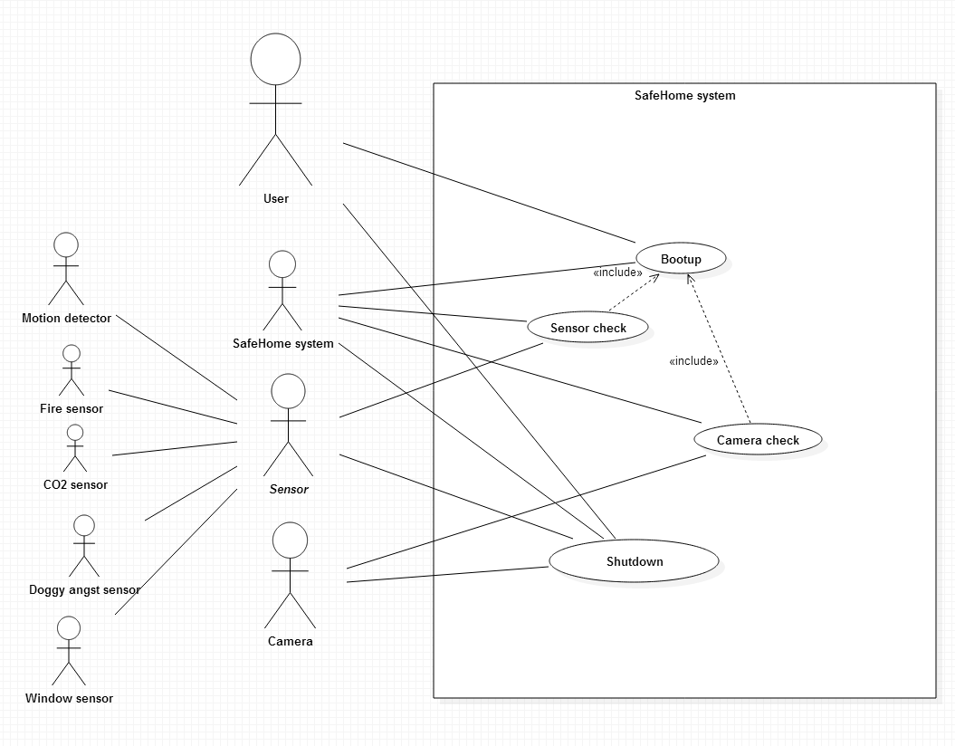

## Configuration service

### Password registration

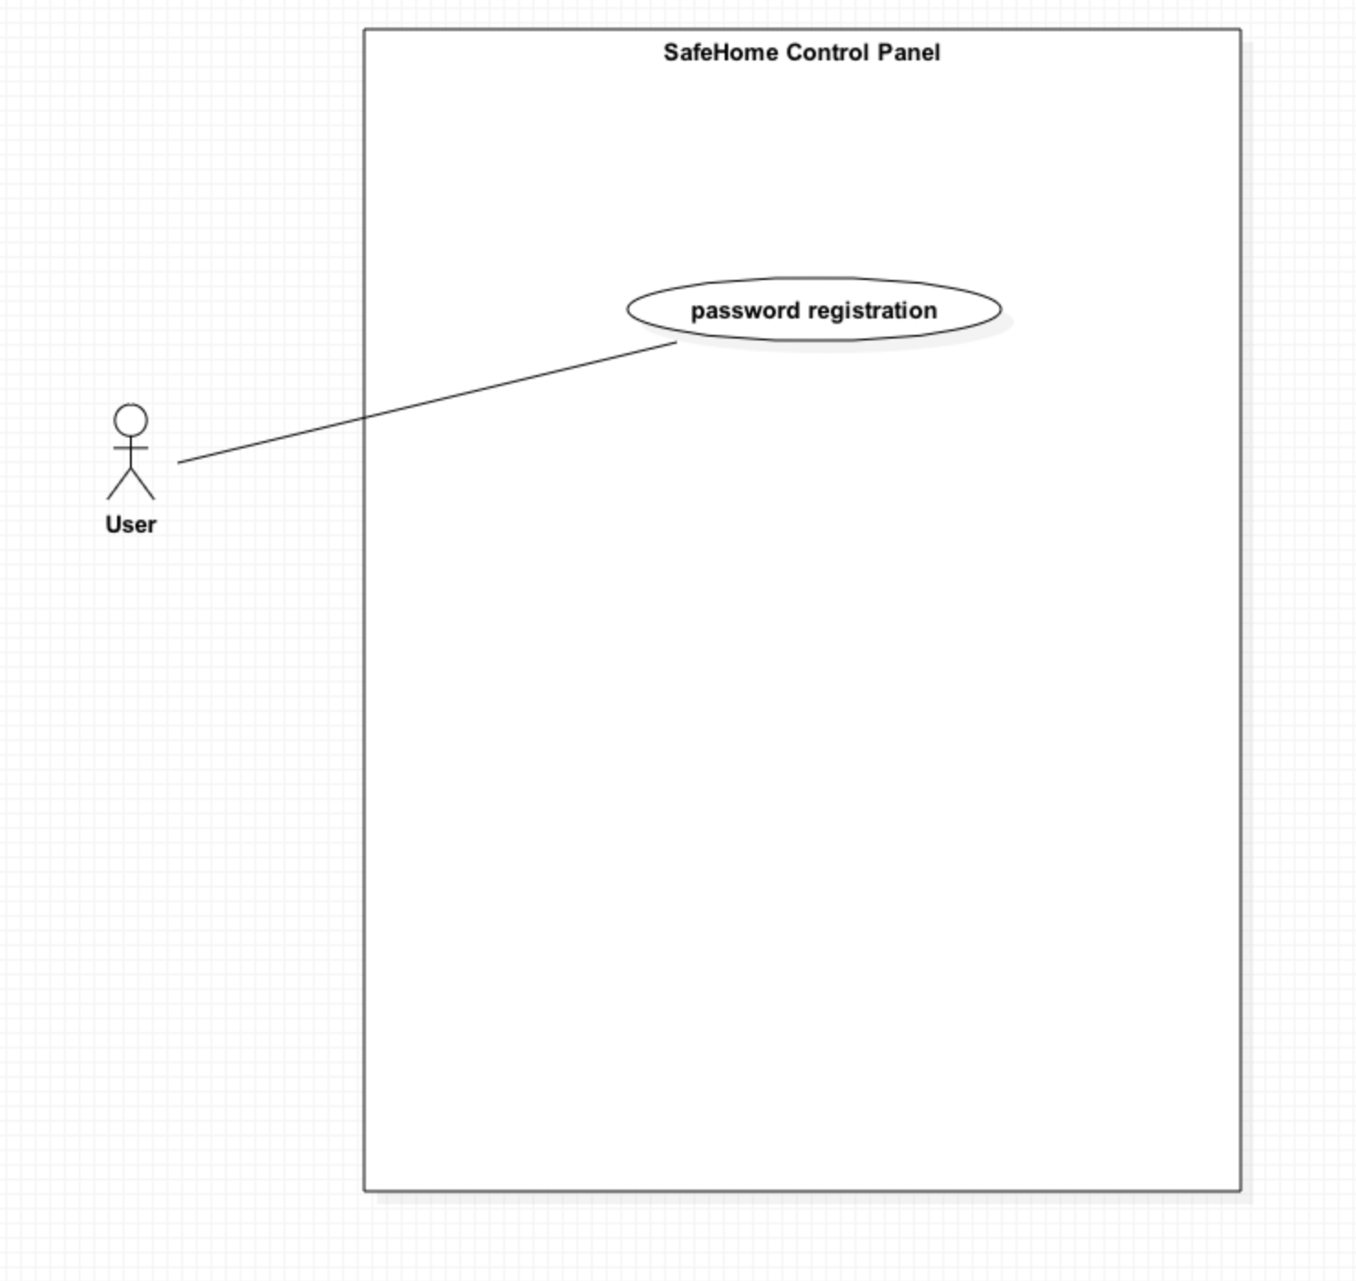

### Password registration (web)

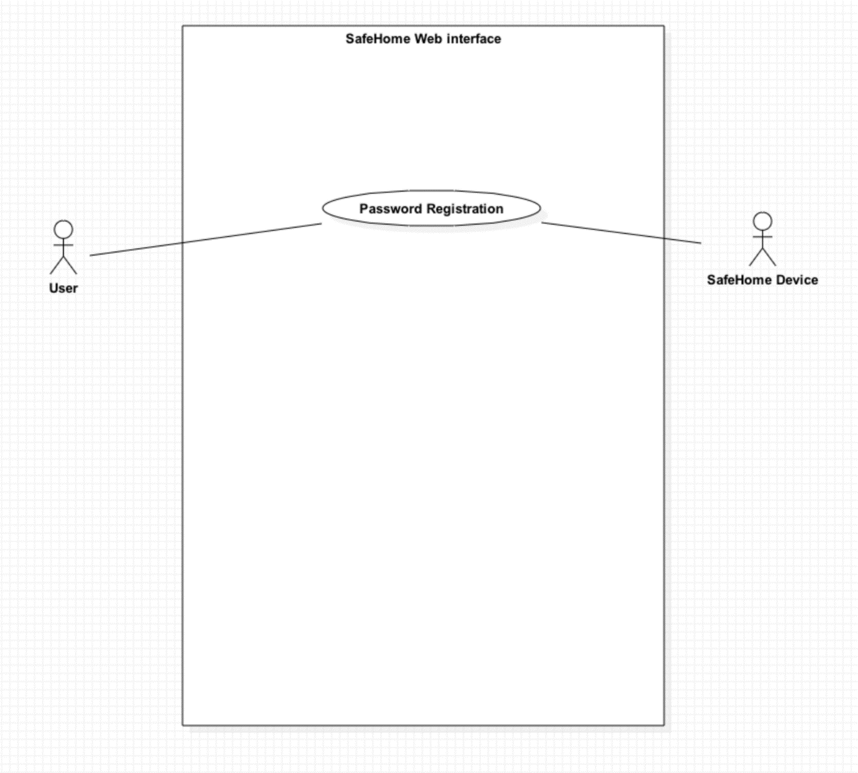

### Grouping devices

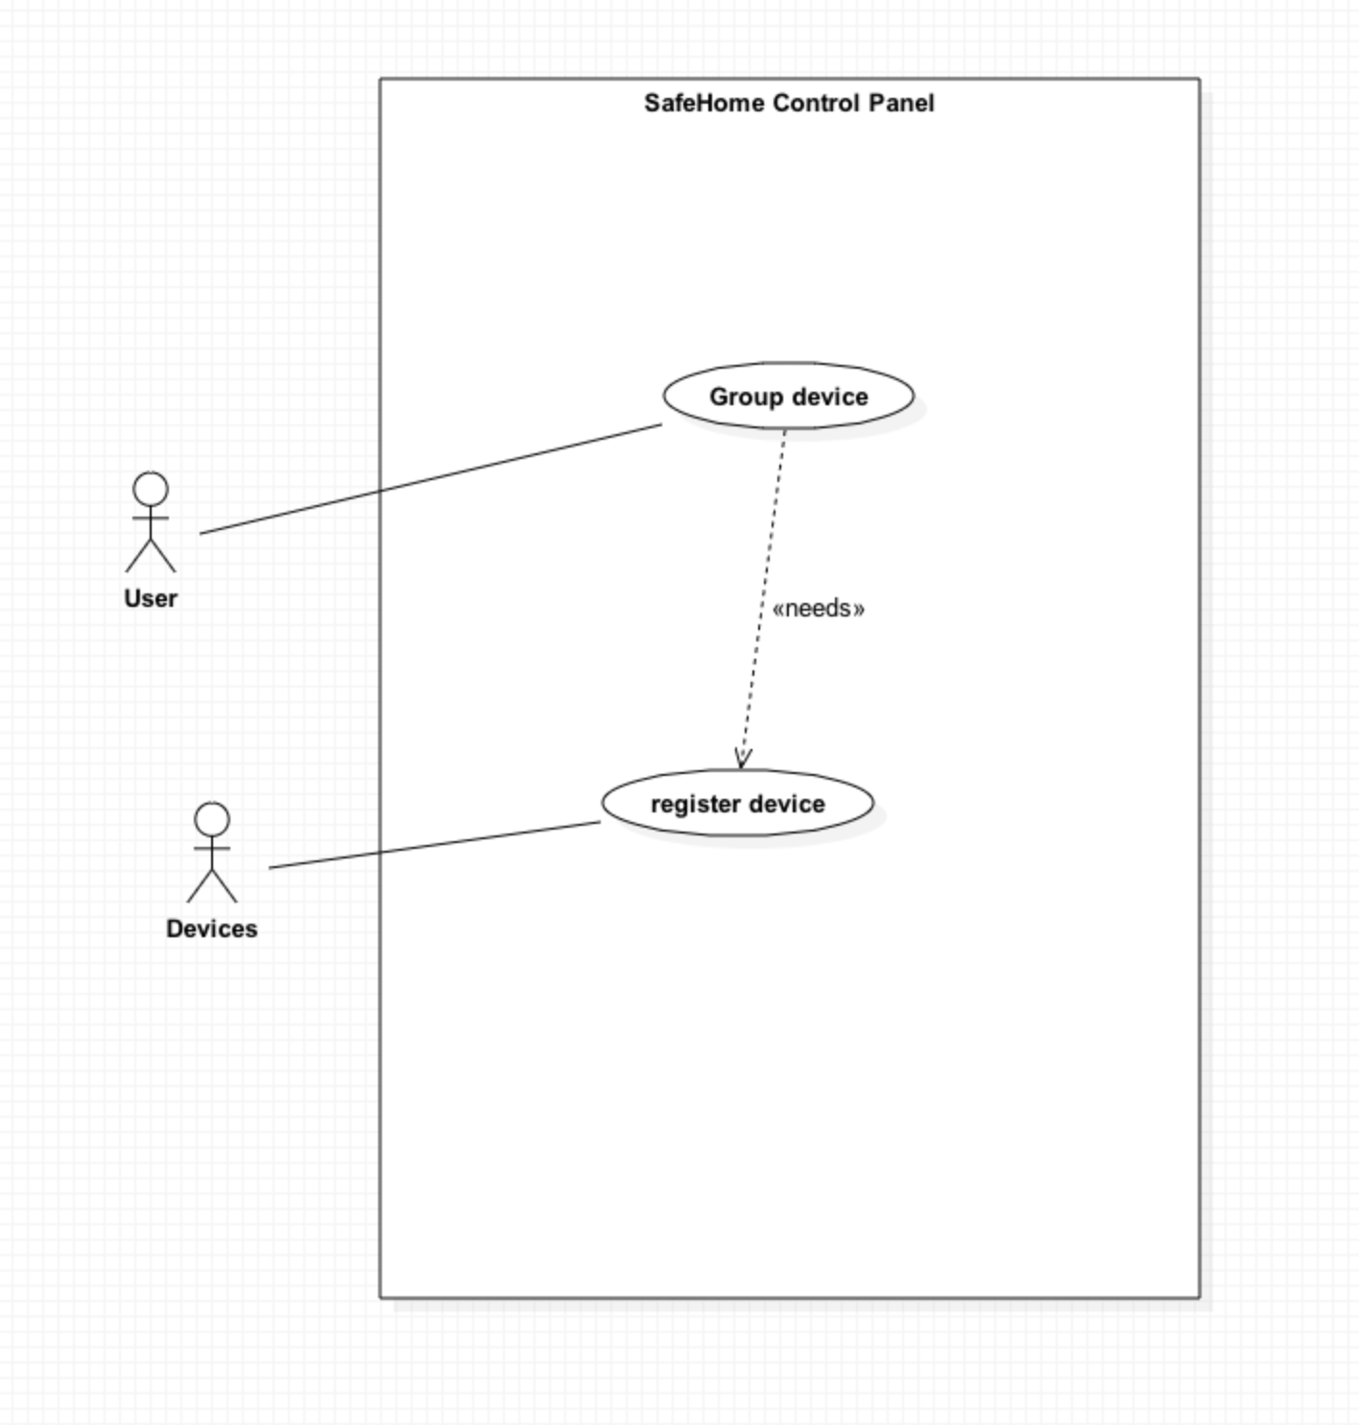

### Web session timeout

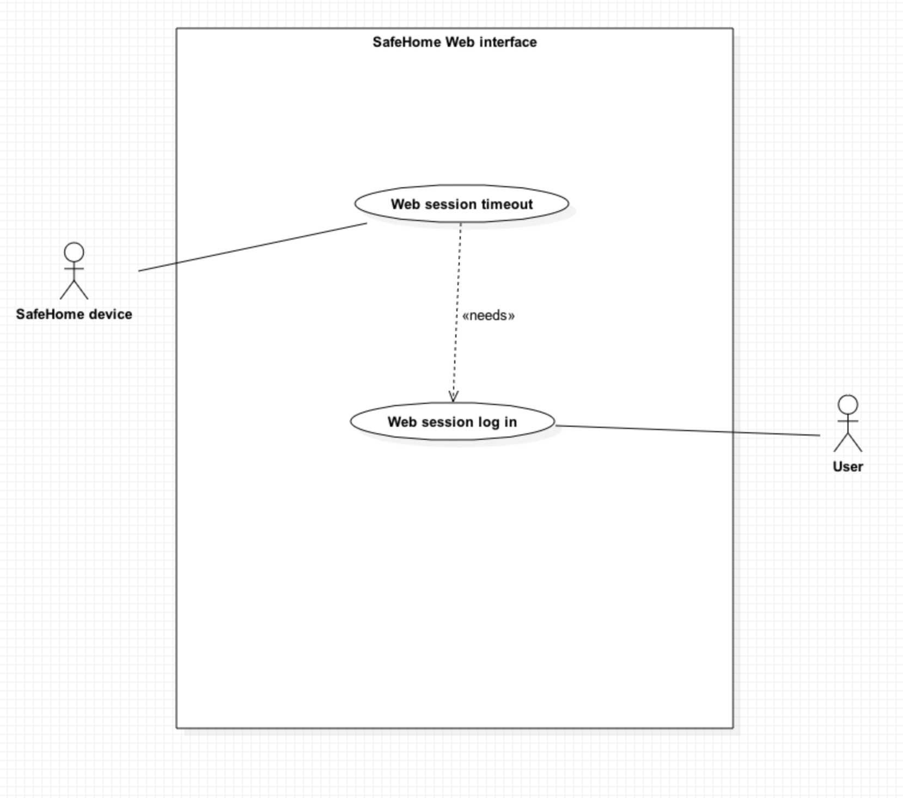

## Real time security service

### Arming-disarming devices and system

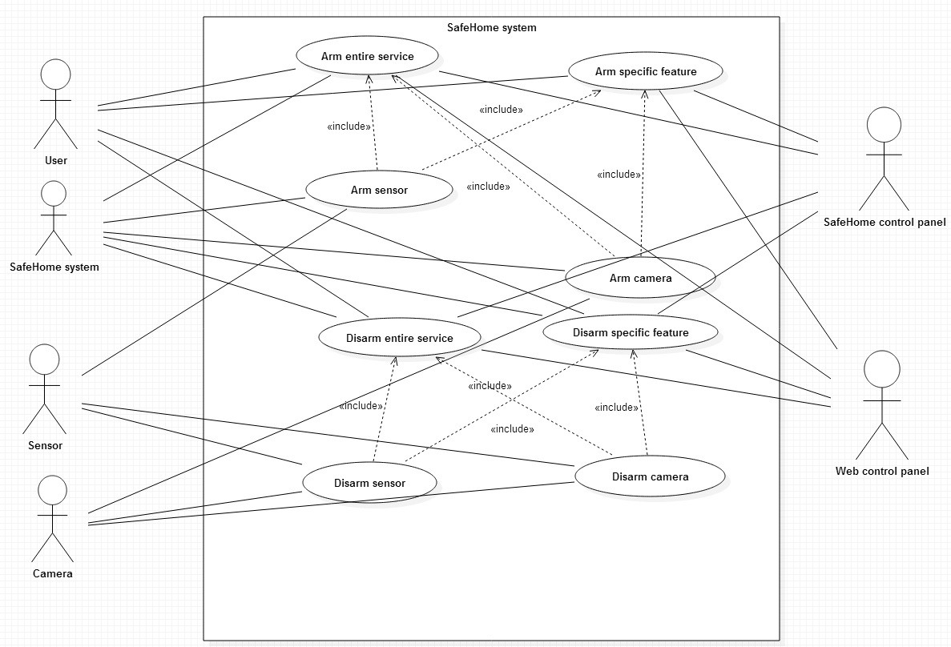

### Setting travel mode

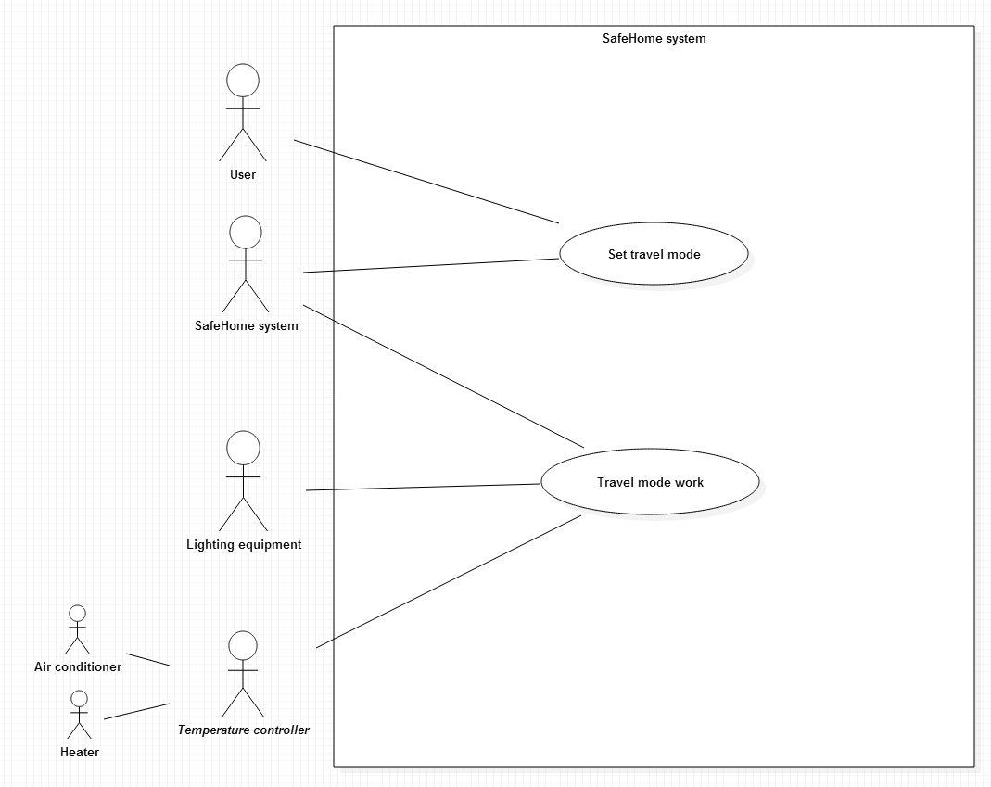

### SafeHome security system(sensor and camera actuator part)

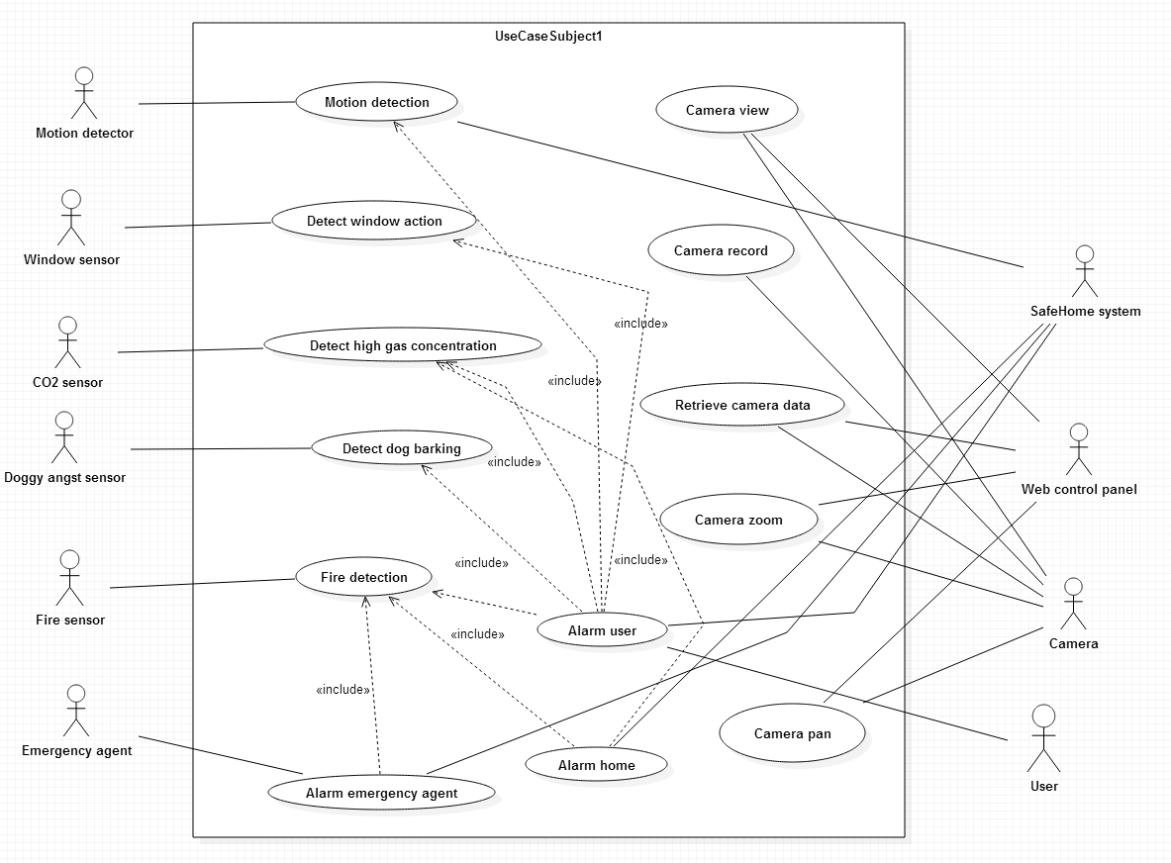

## User-requested information retrieval service

### Retrieve ID and PW

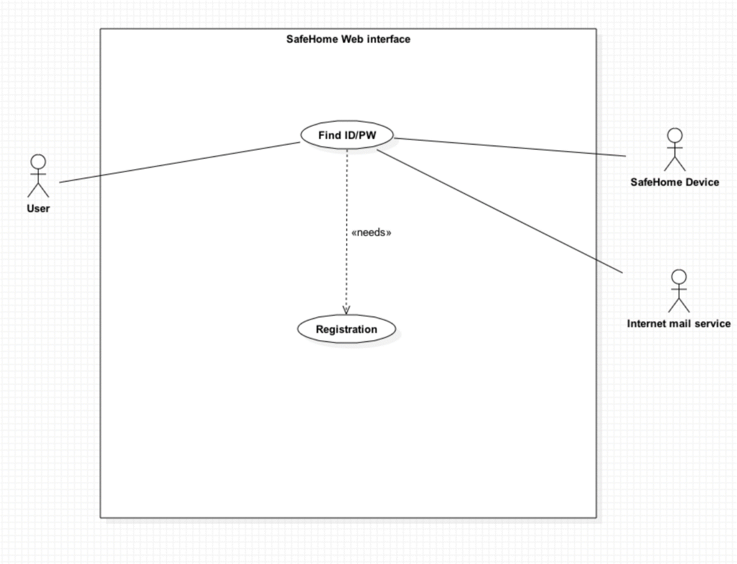

### Report system usage pattern

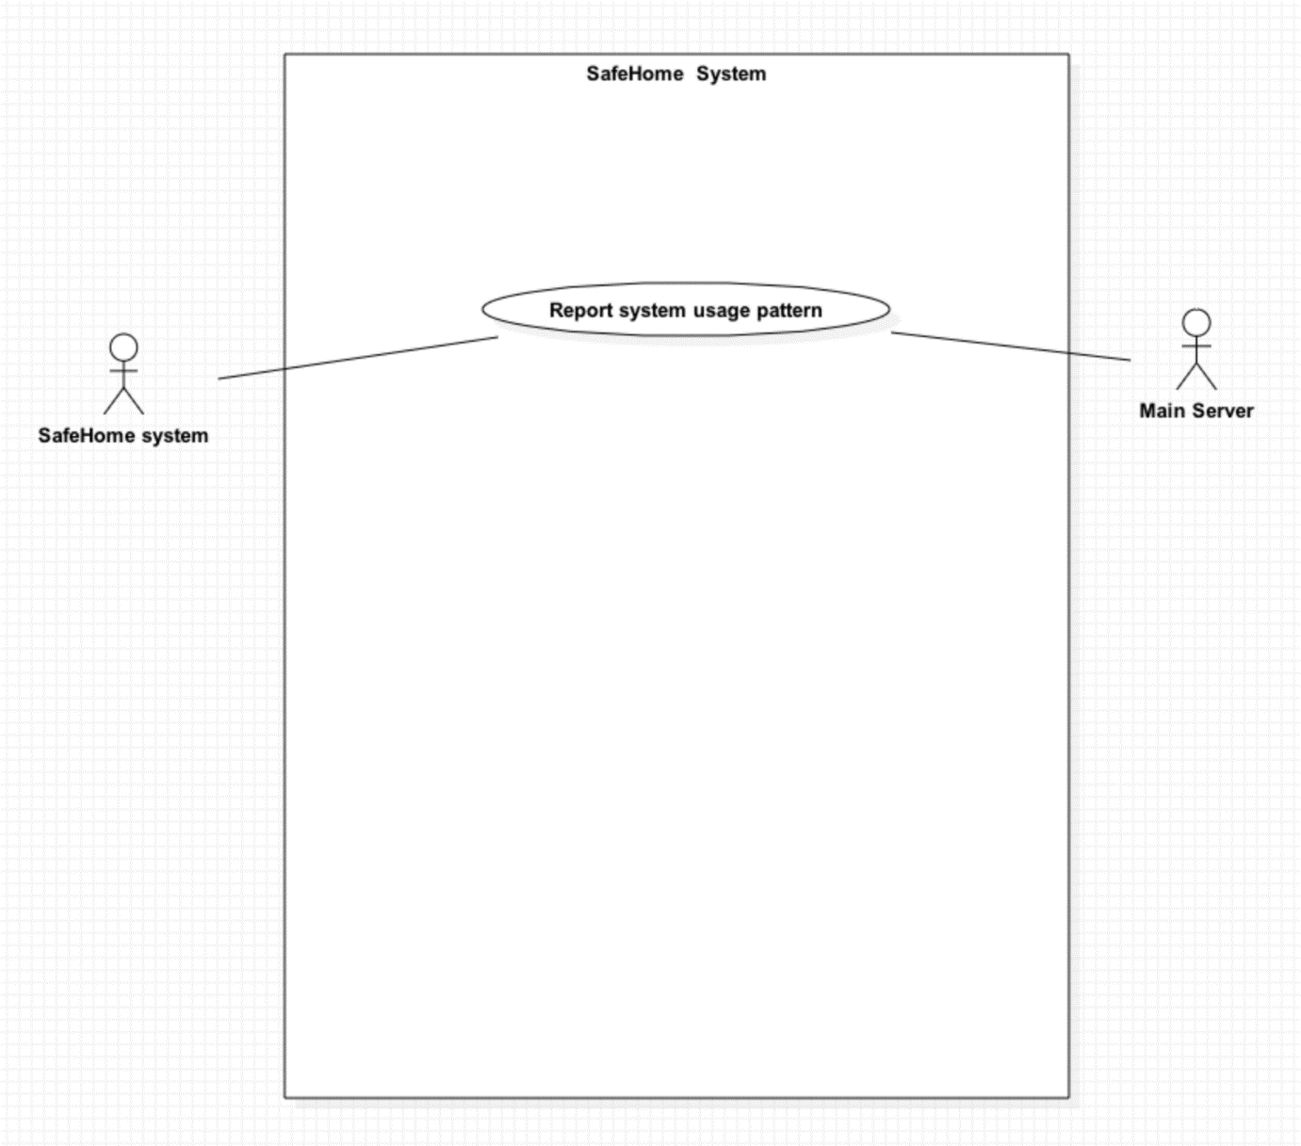

### Report web page access history

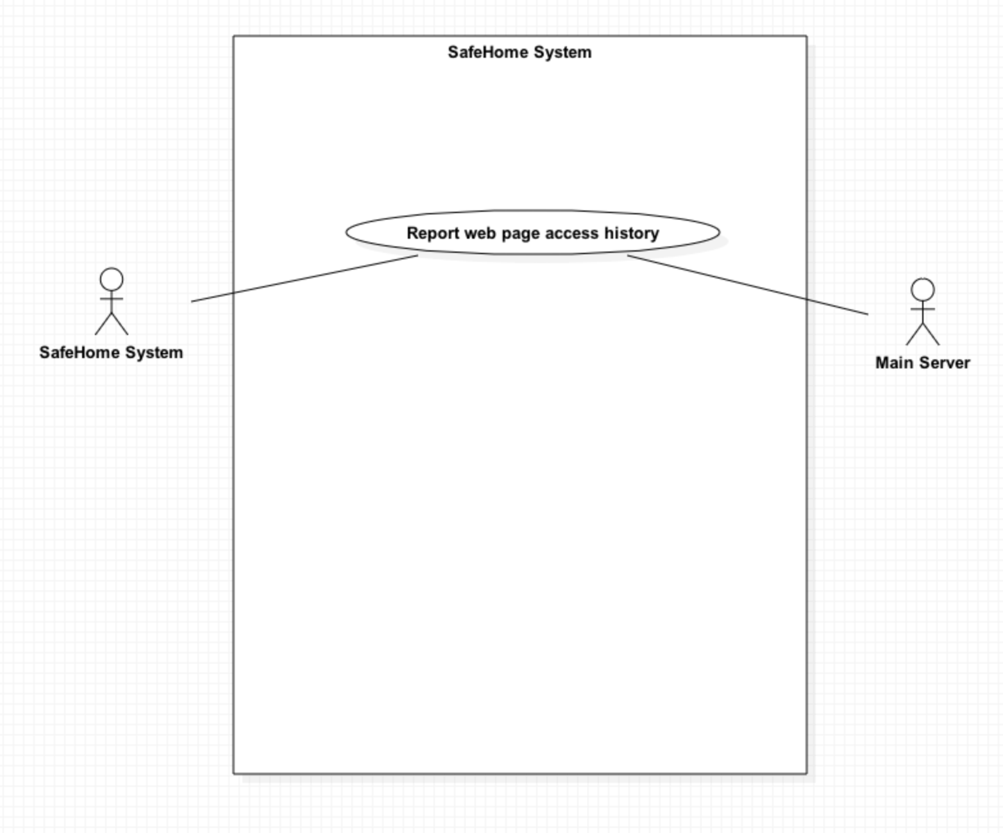

# Use cases

## SafeHome bootup/shutdown service

### SafeHome bootup

|  |  |  |  |  |  |
| --- | --- | --- | --- | --- | --- |
| Use case Number | 3.1.1 | Feature Number | 1 | Frequency of Use | Frequently |
| Created date | 5/4/2015 | Author | Seokju Hong | | |
| Updated date | 5/4/2015 | Updated by | Seokju Hong | Revision # | 0 |
| Priority | High | | | | |
| Primary actor | SafeHome system, User | | | | |
| Title | Bootup | | | | |
| Preconditions | SafeHome system is currently down. | | | | |
| Trigger | The user presses power button of the SafeHome system. | | | | |
| Postconditions | SafeHome system is booted up and perform sensor checking. | | | | |
| Main success scenario | 1. The user presses power button of the SafeHome system. 2. The SafeHome system checks voltage of connected power source. 3. If power source has enough voltage, SafeHome boots up. | | | | |
| Exceptions | 2a. The SafeHome system is not connected to the power source with proper voltage   * 2a1. The SafeHome system aborts to boot up, and shut down. | | | | |

### Sensor check

|  |  |  |  |  |  |
| --- | --- | --- | --- | --- | --- |
| Use case Number | 3.1.2 | Feature Number | 1 | Frequency of Use | Frequently |
| Created date | 5/4/2015 | Author | Seokju Hong | | |
| Updated date | 5/4/2015 | Updated by | Seokju Hong | Revision # | 0 |
| Priority | High | | | | |
| Primary actor | SafeHome system, Sensor | | | | |
| Title | Sensor check | | | | |
| Preconditions | SafeHome system is just booted up. | | | | |
| Trigger | Triggered automatically right after booting. | | | | |
| Postconditions | SafeHome system checked all sensors, and perform sensor checking. | | | | |
| Main success scenario | 1. The SafeHome system calls sensor checking method. 2. The SafeHome system sends “MEASURE” message to every sensors. 3. Every sensor sends its current value to the SafeHome system. 4. The SafeHome receives sensors’ message and check every value whether it is in proper range(normal state). | | | | |
| Exceptions | 4a. Sensor value is invalid value or sensor does not send any message to the SafeHome system.(timeout)   * 4a1. The SafeHome system sends “MEASURE” message to the sensor. * 4a2. If checking session fail for 3 times, the SafeHome system makes log about the broken sensor. | | | | |

### Camera check

|  |  |  |  |  |  |
| --- | --- | --- | --- | --- | --- |
| Use case Number | 3.1.3 | Feature Number | 1 | Frequency of Use | Frequently |
| Created date | 5/4/2015 | Author | Seokju Hong | | |
| Updated date | 5/4/2015 | Updated by | Seokju Hong | Revision # | 0 |
| Priority | High | | | | |
| Primary actor | SafeHome system, Camera | | | | |
| Title | Camera check | | | | |
| Preconditions | SafeHome system just checked every sensor. | | | | |
| Trigger | Triggered automatically right after sensor checking. | | | | |
| Postconditions | SafeHome system checked all cameras and ready to operate every system. | | | | |
| Main success scenario | 1. The SafeHome system calls camera checking method. 2. The SafeHome system sends “HELLO” message to every cameras. 3. Every camera sends “OK” message to the SafeHome system. 4. The SafeHome receives sensors’ message. | | | | |
| Exceptions | 4a. The SafeHome system did not received OK, or the message from a camera corrupted.   * 4b1. The SafeHome system sends “HELLO” message again to the camera. * 4b2. If it fails for 3 times, the red LED of the port where the camera connected blinks and the SafeHome system sends message to user that the camera is broken | | | | |

### Shutdown

|  |  |  |  |  |  |
| --- | --- | --- | --- | --- | --- |
| Use case Number | 3.1.4 | Feature Number | 1 | Frequency of Use | Normal |
| Created date | 5/4/2015 | Author | Seokju Hong | | |
| Updated date | 5/4/2015 | Updated by | Seokju Hong | Revision # | 0 |
| Priority | High | | | | |
| Primary actor | SafeHome system, Camera, Sensor, User | | | | |
| Title | Shutdown | | | | |
| Preconditions | SafeHome system is operating currently. | | | | |
| Trigger | The user presses power button of the SafeHome system for 3 seconds. | | | | |
| Postconditions | SafeHome system is down. | | | | |
| Main success scenario | 1. The user presses power button of the SafeHome system for 3 seconds 2. The SafeHome system sends “QUIT” message to every sensor and camera. 3. Every sensor and camera sends “OK” message to the SafeHome system and shuts down. 4. If the SafeHome system received “OK” message from every cameras and sensors, the SafeHome system shuts down. | | | | |
| Exceptions | 4a. The SafeHome system did not received OK for 10 seconds.   * 4b1. The SafeHome system forces to shut the sensor or the camera down, and shuts down. | | | | |

## SafeHome configuration service

### 3.2.1. Password registration – Control panel

|  |  |  |  |  |  |
| --- | --- | --- | --- | --- | --- |
| Use case Number | 3.2.1 | Feature Number | 2 | Frequency of Use | Rare, first time only |
| Created date | 5/4/2015 | Author | Young Seok Kim | | |
| Updated date | 5/4/2015 | Updated by | Young Seok Kim | Revision # | 0 |
| Priority | High | | | | |
| Primary actor | SafeHome system, User | | | | |
| Title | Password Registration – Control panel | | | | |
| Preconditions | SafeHome system password is not set | | | | |
| Trigger | User first boots up SafeHome system | | | | |
| Postconditions | SafeHome system password setting is finished | | | | |
| Main success scenario | 1. User first boots up SafeHome system. 2. Password registration screen shows up. 3. User enters valid password and presses ‘done’ button 4. The password is registered to SafeHome system | | | | |
| Exceptions | 3a. User enters invalid password (must be 4 digits)   * 3a1. SafeHome system shows error message – “invalid password” and asks the user to enter password again. | | | | |

### Password registration – Web

|  |  |  |  |  |  |
| --- | --- | --- | --- | --- | --- |
| Use case Number | 3.2.2 | Feature Number | 2 | Frequency of Use | Rare, first time only |
| Created date | 5/4/2015 | Author | Young Seok Kim | | |
| Updated date | 5/4/2015 | Updated by | Young Seok Kim | Revision # | 0 |
| Priority | High | | | | |
| Primary actor | SafeHome system, User | | | | |
| Title | Password Registration - Web | | | | |
| Preconditions | SafeHome system password is set.  Web interface password is not set. | | | | |
| Trigger | User accesses registration page in SafeHome web interface | | | | |
| Postconditions | Safehome Web interface password setting is finished | | | | |
| Main success scenario | 1. User accesses SafeHome web interface 2. User enters SafeHome system password and DeviceID 3. Web interface asks Web interface password. 4. User enters valid web interface password | | | | |
| Exceptions | 3a. User enters invalid password (must be 8 alphanumeric character)   * 3a1. SafeHome system shows error message – “invalid password” and asks the user to enter password again. | | | | |

### Grouping devices

|  |  |  |  |  |  |
| --- | --- | --- | --- | --- | --- |
| Use case Number | 3.2.3 | Feature Number | 2 | Frequency of Use | Rare |
| Created date | 5/4/2015 | Author | Young Seok Kim | | |
| Updated date | 5/4/2015 | Updated by | Young Seok Kim | Revision # | 0 |
| Priority | Medium | | | | |
| Primary actor | SafeHome system, User, devices | | | | |
| Title | Grouping devices | | | | |
| Preconditions | Devices are properly installed to SafeHome system | | | | |
| Trigger | User accesses grouping device screen on SafeHome system | | | | |
| Postconditions | SafeHome devices are grouped together to be manipulated as groups | | | | |
| Main success scenario | 1. User access grouping device screen on SafeHome system 2. User selects 1 or more devices and presses ‘done’ button 3. Selected devices are registered as groups | | | | |
| Exceptions | 2a. User didn’t select any device and press enter   * 2a1. SafeHome system shows error message – “empty group” and asks the user to select devices again. | | | | |

### Web session timeout

|  |  |  |  |  |  |
| --- | --- | --- | --- | --- | --- |
| Use case Number | 3.2.4 | Feature Number | 2 | Frequency of Use | Often |
| Created date | 5/4/2015 | Author | Young Seok Kim | | |
| Updated date | 5/4/2015 | Updated by | Young Seok Kim | Revision # | 0 |
| Priority | High | | | | |
| Primary actor | SafeHome system, User, password | | | | |
| Title | Web session timeout | | | | |
| Preconditions | User is currently logged in to the SafeHome system | | | | |
| Trigger | The user is inactive for 5 minutes | | | | |
| Postconditions | The user is logged out | | | | |
| Main success scenario | 1. User logs in to the SafeHome web interface 2. User has no input for 5 minutes 3. The user session is timed out and the user is automatically logged out | | | | |
| Exceptions |  | | | | |

## SafeHome real-time security service

### Arm-system

|  |  |  |  |  |  |
| --- | --- | --- | --- | --- | --- |
| Use case Number | 3.3.1 | Feature Number | 3 | Frequency of Use | Frequently |
| Created date | 5/5/2015 | Author | Seokju Hong | | |
| Updated date | 5/5/2015 | Updated by | Seokju Hong | Revision # | 0 |
| Priority | High | | | | |
| Primary actor | SafeHome system, Camera, Sensor, User | | | | |
| Title | Arm-system | | | | |
| Preconditions | User logged into the control panel, or logged into the web control panel. | | | | |
| Trigger | Two possible cases:   1. User presses arm-system button on the control panel 2. User presses arm-system button on the web page of the SafeHome system. | | | | |
| Postconditions | Every sensors, cameras are armed. | | | | |
| Main success scenario | 1. The user presses arm-system button on the control panel, or the user presses arm-system button on the web page of the SafeHome system. 2. The SafeHome system checks every sensors and cameras whether it is armed or not. 3. For every sensor/camera that is not armed, call arm function for those disarmed devices. | | | | |
| Exceptions | 3a. Arming a device failed.   * 3a1. Make a log for failed devices that the devices failed to be armed. | | | | |

### Arm-device

|  |  |  |  |  |  |
| --- | --- | --- | --- | --- | --- |
| Use case Number | 3.3.2 | Feature Number | 3 | Frequency of Use | Frequently |
| Created date | 5/5/2015 | Author | Seokju Hong | | |
| Updated date | 5/5/2015 | Updated by | Seokju Hong | Revision # | 0 |
| Priority | High | | | | |
| Primary actor | SafeHome system, Camera, Sensor, User | | | | |
| Title | Arm-device | | | | |
| Preconditions | User logged into the control panel, or logged into the web control panel. | | | | |
| Trigger | Two possible cases:   1. User presses arm-device button on the control panel 2. User presses arm-device button on the web page of the SafeHome system. | | | | |
| Postconditions | Selected sensor/camera is armed. | | | | |
| Main success scenario | 1. User selects devices that he or she wants to make armed. 2. Call arm function for the selected device (sensor or camera). | | | | |
| Exceptions | 2a. Arming a device failed.   * 2b1. Make a log for failed device that the device failed to be armed. | | | | |

### Disarm-system

|  |  |  |  |  |  |
| --- | --- | --- | --- | --- | --- |
| Use case Number | 3.3.3 | Feature Number | 3 | Frequency of Use | Frequently |
| Created date | 5/5/2015 | Author | Seokju Hong | | |
| Updated date | 5/5/2015 | Updated by | Seokju Hong | Revision # | 0 |
| Priority | High | | | | |
| Primary actor | SafeHome system, Camera, Sensor, User | | | | |
| Title | Disarm-system | | | | |
| Preconditions | User logged into the control panel, or logged into the web control panel. | | | | |
| Trigger | Two possible cases:   1. User presses disarm-system button on the control panel 2. User presses disarm-system button on the web page of the SafeHome system. | | | | |
| Postconditions | Every sensor, camera is disarmed. | | | | |
| Main success scenario | 1. The user presses disarm-system button on the control panel, or the user presses disarm-system button on the web page of the SafeHome system. 2. The SafeHome system checks every sensors and cameras whether it is armed or not. 3. For every sensor/camera that is armed, call disarm function for those armed devices. | | | | |
| Exceptions | 3a. Disarming a device failed.   * 3a1. The SafeHome system retries to disarm the device. * 3a2. If it fails 3 times, the SafeHome system forces to disarm the device. | | | | |

### Disarm-device

|  |  |  |  |  |  |
| --- | --- | --- | --- | --- | --- |
| Use case Number | 3.3.4 | Feature Number | 3 | Frequency of Use | Frequently |
| Created date | 5/5/2015 | Author | Seokju Hong | | |
| Updated date | 5/5/2015 | Updated by | Seokju Hong | Revision # | 0 |
| Priority | High | | | | |
| Primary actor | SafeHome system, Camera, Sensor, User | | | | |
| Title | Disarm-device | | | | |
| Preconditions | User logged into the control panel, or logged into the web control panel. | | | | |
| Trigger | Two possible cases:   1. User presses disarm-device button on the control panel 2. User presses disarm-device button on the web page of the SafeHome system. | | | | |
| Postconditions | Selected sensor/camera is armed. | | | | |
| Main success scenario | 1. User selects devices that he or she wants to make disarmed. 2. Call disarm function for the selected device (sensor or camera). | | | | |
| Exceptions | 2a. Disarming a device failed.   * 2b1. The SafeHome system retries to disarm the device. * 2a2. If it fails 3 times, the SafeHome system forces to disarm the device. | | | | |

### Alarm-house

|  |  |  |  |  |  |
| --- | --- | --- | --- | --- | --- |
| Use case Number | 3.3.5 | Feature Number | 3 | Frequency of Use | Rarely |
| Created date | 5/5/2015 | Author | Seokju Hong | | |
| Updated date | 5/5/2015 | Updated by | Seokju Hong | Revision # | 0 |
| Priority | High | | | | |
| Primary actor | SafeHome system, Sensor, User | | | | |
| Title | Alarm-house | | | | |
| Preconditions | The SafeHome system is currently operating.  There is abnormality with toxic, water level, or fire and corresponding sensor is armed.  Alarming house function is armed. | | | | |
| Trigger | Sensor detects abnormality with its measured value. | | | | |
| Postconditions | Alarm rings over the house. | | | | |
| Main success scenario | 1. The sensor detects abnormalities with fire, toxic, water level, … 2. The sensor calls alarmHouse() function and alarm rings. | | | | |
| Exceptions |  | | | | |

### Alarm-user

|  |  |  |  |  |  |
| --- | --- | --- | --- | --- | --- |
| Use case Number | 3.3.6 | Feature Number | 3 | Frequency of Use | Rarely |
| Created date | 5/5/2015 | Author | Seokju Hong | | |
| Updated date | 5/5/2015 | Updated by | Seokju Hong | Revision # | 0 |
| Priority | Normal | | | | |
| Primary actor | SafeHome system, Sensor, User | | | | |
| Title | Alarm-user | | | | |
| Preconditions | The SafeHome system is currently operating.  There is abnormality with toxic, water level, or fire and corresponding sensor is armed.  Alarming user function is armed.  User’s contact information is registered to the SafeHome system. | | | | |
| Trigger | Sensor detects abnormality with fire, toxic, water level, … | | | | |
| Postconditions | The user receives SMS message from the SafeHome system. | | | | |
| Main success scenario | 1. The sensor detects abnormalities with fire, toxic, water level, … 2. The sensor calls alarmUser() function. 3. The SafeHome system sends SMS message to the user that there is a problem in the house. | | | | |
| Exceptions |  | | | | |

### Alarm-emergency-agent

|  |  |  |  |  |  |
| --- | --- | --- | --- | --- | --- |
| Use case Number | 3.3.7 | Feature Number | 3 | Frequency of Use | Rarely |
| Created date | 5/5/2015 | Author | Seokju Hong | | |
| Updated date | 5/5/2015 | Updated by | Seokju Hong | Revision # | 0 |
| Priority | High | | | | |
| Primary actor | SafeHome system, Sensor, User, Emergency agent(119) | | | | |
| Title | Alarm-emergency-agent | | | | |
| Preconditions | The SafeHome system is currently operating.  There is abnormality with toxic, water level, or fire and corresponding sensor is armed.  Alarming emergency agent function is armed.  User’s address information is registered to the SafeHome system. | | | | |
| Trigger | Sensor detects abnormality with its measured value. | | | | |
| Postconditions | Emergency agent receives emergent message from the SafeHome system. | | | | |
| Main success scenario | 1. The sensor detects abnormalities with fire, toxic, water level, … 2. The sensor calls alarmEmergencyAgent() function. 3. The SafeHome system sends message to emergency agents(like 119) that there is a problem in the house. | | | | |
| Exceptions |  | | | | |

### Set travel mode

|  |  |  |  |  |  |
| --- | --- | --- | --- | --- | --- |
| Use case Number | 3.3.8 | Feature Number | 3 | Frequency of Use | Frequently |
| Created date | 5/5/2015 | Author | Seokju Hong | | |
| Updated date | 5/5/2015 | Updated by | Seokju Hong | Revision # | 0 |
| Priority | High | | | | |
| Primary actor | SafeHome system, User, Lighting equipment, Heater, Air conditioner | | | | |
| Title | Set travel mode | | | | |
| Preconditions | User logged into the control panel, or logged into the web control panel. | | | | |
| Trigger | 1. User presses travel mode change button on the control panel 2. User presses travel mode change button on the web page of the SafeHome system. | | | | |
| Postconditions | Either normal, away, overnight travel, extended travel mode is set.  The SafeHome system turns light, heater, air conditioner on and off at random interval. | | | | |
| Main success scenario | 1. User selects 1 mode over 4 modes(normal, away, overnight travel, extended travel) 2. The SafeHome system randomly generates time interval and schedule working time of lighting equipment, heater, and air conditioner. | | | | |
| Exceptions |  | | | | |

### Detect motion

|  |  |  |  |  |  |
| --- | --- | --- | --- | --- | --- |
| Use case Number | 3.3.9 | Feature Number | 3 | Frequency of Use | Everyday |
| Created date | 5/5/2015 | Author | Seokju Hong | | |
| Updated date | 5/5/2015 | Updated by | Seokju Hong | Revision # | 0 |
| Priority | Normal | | | | |
| Primary actor | Motion detector, SafeHome system | | | | |
| Title | Detect motion | | | | |
| Preconditions | The SafeHome is booted up.  Motion detection feature is armed. | | | | |
| Trigger | Motion is detected by motion detector. | | | | |
| Postconditions | Motion detector calls alarmUser() function. | | | | |
| Main success scenario | 1. Strange object moves around the motion detector. 2. Motion detector detects the object. 3. The motion detector calls alarmUser() function to notify user that there’s something strange moving in the house. | | | | |
| Exceptions | 3a. User alarming feature is not armed.   * Abort alarming user. | | | | |

### Detect window action

|  |  |  |  |  |  |
| --- | --- | --- | --- | --- | --- |
| Use case Number | 3.3.10 | Feature Number | 3 | Frequency of Use | Everyday |
| Created date | 5/5/2015 | Author | Seokju Hong | | |
| Updated date | 5/5/2015 | Updated by | Seokju Hong | Revision # | 0 |
| Priority | Normal | | | | |
| Primary actor | Window sensor, SafeHome system | | | | |
| Title | Detect window action | | | | |
| Preconditions | The SafeHome is booted up.  Window action detection feature is armed. | | | | |
| Trigger | Any window is opened. | | | | |
| Postconditions | Motion detector calls alarmUser() function. | | | | |
| Main success scenario | 1. Strange object opens window. 2. Window sensor detects that the window is opened.. 3. The window sensor calls alarmUser() function to notify user that the stranger just opened the window.. | | | | |
| Exceptions | 3a. User alarming feature is not armed.   * Abort alarming user. | | | | |

### Detect high gas concentration

|  |  |  |  |  |  |
| --- | --- | --- | --- | --- | --- |
| Use case Number | 3.3.11 | Feature Number | 3 | Frequency of Use | Everyday |
| Created date | 5/5/2015 | Author | Seokju Hong | | |
| Updated date | 5/5/2015 | Updated by | Seokju Hong | Revision # | 0 |
| Priority | Normal | | | | |
| Primary actor | CO2 sensor, SafeHome system | | | | |
| Title | Detect high gas concentration | | | | |
| Preconditions | The SafeHome is booted up.  Sensing gas concentration feature is armed. | | | | |
| Trigger | CO2 concentration is higher than threshold value. | | | | |
| Postconditions | CO2 sensor calls alarmHome(), alarmUser() function. | | | | |
| Main success scenario | 1. CO2 gas level increases. 2. CO2 sensor detects that CO2 level is higher than threshold. 3. The CO2 sensor calls alarmHome(), alarmUser() function to notify user and people in the house that current CO2 level is too high. | | | | |
| Exceptions | 3a. User alarming feature is not armed.   * Abort alarming user.   3b. Home alarming feature is not armed.   * Abort alarming home. | | | | |

### Fire detection

|  |  |  |  |  |  |
| --- | --- | --- | --- | --- | --- |
| Use case Number | 3.3.12 | Feature Number | 3 | Frequency of Use | Everyday |
| Created date | 5/5/2015 | Author | Seokju Hong | | |
| Updated date | 5/5/2015 | Updated by | Seokju Hong | Revision # | 0 |
| Priority | Normal | | | | |
| Primary actor | Fire sensor, SafeHome system, Emergency agent | | | | |
| Title | Fire detection | | | | |
| Preconditions | The SafeHome is booted up.  Sensing fire feature is armed. | | | | |
| Trigger | Fire outbreaks over the house. | | | | |
| Postconditions | Fire sensor calls alarmHome(), alarmUser(), alarmEmergencyAgent() function. | | | | |
| Main success scenario | 1. Fire outbreaks over the house. 2. Fire detected by the fire sensor. 3. The fire sensor calls alarmHome(), alarmUser(), alarmEmergencyAgent() function to notify user and people in the house that house is on fire. 4. Emergency agent receives emergency message from the SafeHome system. 5. Emergency agents come to the house and tries to extinguish. | | | | |
| Exceptions | 3a. User alarming feature is not armed.   * Abort alarming user.   3b. Home alarming feature is not armed.   * Abort alarming home. | | | | |

### Detect dog barking

|  |  |  |  |  |  |
| --- | --- | --- | --- | --- | --- |
| Use case Number | 3.3.13 | Feature Number | 3 | Frequency of Use | Everyday |
| Created date | 5/5/2015 | Author | Seokju Hong | | |
| Updated date | 5/5/2015 | Updated by | Seokju Hong | Revision # | 0 |
| Priority | Low | | | | |
| Primary actor | Doggy angst sensor, SafeHome system | | | | |
| Title | Detect dog barking | | | | |
| Preconditions | The SafeHome is booted up.  Dog barking detection feature is armed. | | | | |
| Trigger | Dog barks loudly | | | | |
| Postconditions | Doggy angst sensor calls alarmUser() function. | | | | |
| Main success scenario | 1. Dog barks loudly. 2. Doggy angst sensor detects dog barks loudly. 3. Doggy angst sensor calls alarmUser() function, and the user get SMS message from the SafeHome system. | | | | |
| Exceptions | 3a. User alarming feature is not armed.   * Abort alarming user. | | | | |

### Camera view

|  |  |  |  |  |  |
| --- | --- | --- | --- | --- | --- |
| Use case Number | 3.3.14 | Feature Number | 3 | Frequency of Use | Normal |
| Created date | 5/6/2015 | Author | Seokju Hong | | |
| Updated date | 5/6/2015 | Updated by | Seokju Hong | Revision # | 0 |
| Priority | High | | | | |
| Primary actor | SafeHome system, Camera, User | | | | |
| Title | Camera view | | | | |
| Preconditions | User has logged into the SafeHome web page control panel. | | | | |
| Trigger | User clicks “View CCTV camera” button on the SafeHome web page control panel. | | | | |
| Postconditions | User can see what camera captures real-time. | | | | |
| Main success scenario | 1. User clicks “Overview CCTV camera” button on the SafeHome web page control panel. 2. User can monitor his/her entire room by watching thumbnail view of every camera. 3. User selects available CCTV. 4. User can monitor his/her room with CCTV scenes. | | | | |
| Exceptions |  | | | | |

### Camera record

|  |  |  |  |  |  |
| --- | --- | --- | --- | --- | --- |
| Use case Number | 3.3.15 | Feature Number | 3 | Frequency of Use | Normal |
| Created date | 5/6/2015 | Author | Seokju Hong | | |
| Updated date | 5/6/2015 | Updated by | Seokju Hong | Revision # | 0 |
| Priority | High | | | | |
| Primary actor | SafeHome system, Camera | | | | |
| Title | Camera record | | | | |
| Preconditions | User has logged into the SafeHome control panel.  Camera is armed and passed checking session. | | | | |
| Trigger | Invoked automatically as soon as checking session is finished. | | | | |
| Postconditions | The data that camera captures is saved into the HDD of the SafeHome system. | | | | |
| Main success scenario | 1. The SafeHome finishes checking session. 2. For every camera c, the SafeHome system calls c.record() method. 3. Every camera starts recording. | | | | |
| Exceptions | 2a. HDD space is not enough.   * 2a1. Every camera stops recording. * 2a2. Camera calls alarmUser() to notify that HDD must be swapped. | | | | |

### Retrieve CCTV data

|  |  |  |  |  |  |
| --- | --- | --- | --- | --- | --- |
| Use case Number | 3.3.16 | Feature Number | 3 | Frequency of Use | Normal |
| Created date | 5/6/2015 | Author | Seokju Hong | | |
| Updated date | 5/6/2015 | Updated by | Seokju Hong | Revision # | 0 |
| Priority | Medium | | | | |
| Primary actor | SafeHome system, User | | | | |
| Title | Retrieve CCTV data | | | | |
| Preconditions | CCTV surveillance system is activated.  User logged into the SafeHome web page control panel. | | | | |
| Trigger | The user presses “retrieve camera data” button. | | | | |
| Postconditions | The user saves a part of camera data into his/her external memory. | | | | |
| Main success scenario | 1. User pushes “retrieve” button on the SafeHome web page control panel. 2. User connects USB memory to the SafeHome web page control panel. 3. The SafeHome asks user what camera data user will retrieve. 4. User inputs camera number and date/time range. 5. The SafeHome box copies CCTV data recorded in the input range. | | | | |
| Exceptions | 5a. Camera ID is not applicable   * 5a1. Print error message “Camera ID is not applicable.” and go back to step 5.   5b. Date/time range is not available   * 5b1. Print error message “Datetime range is not available.” and go back to step 5.   6a. Available space in the USB memory is not enough   * 6a1. Print error message “Not enough spaces in the memory” and go back to step 5. | | | | |

### Camera zoom

|  |  |  |  |  |  |
| --- | --- | --- | --- | --- | --- |
| Use case Number | 3.3.17 | Feature Number | 3 | Frequency of Use | Normal |
| Created date | 5/6/2015 | Author | Seokju Hong | | |
| Updated date | 5/6/2015 | Updated by | Seokju Hong | Revision # | 0 |
| Priority | Medium | | | | |
| Primary actor | SafeHome system, Camera | | | | |
| Title | Camera zoom | | | | |
| Preconditions | User has logged into the SafeHome web page control panel.  User is using camera viewing feature. | | | | |
| Trigger | User presses zoom button | | | | |
| Postconditions | Selected camera zooms in or out. | | | | |
| Main success scenario | 1. User is using camera viewing feature. 2. User presses zoom button. 3. User presses either zoom in or zoom out button. | | | | |
| Exceptions | 3a. User zoomed in until its limit and user tries to zoom in more.   * 3a1. Abort zoom-in.   3b. User zoomed out until its limit and user tries to zoom out more.   * 3b1. Abort zoom-out. | | | | |

### Camera pan

|  |  |  |  |  |  |
| --- | --- | --- | --- | --- | --- |
| Use case Number | 3.3.18 | Feature Number | 3 | Frequency of Use | Normal |
| Created date | 5/6/2015 | Author | Seokju Hong | | |
| Updated date | 5/6/2015 | Updated by | Seokju Hong | Revision # | 0 |
| Priority | Medium | | | | |
| Primary actor | SafeHome system, Camera | | | | |
| Title | Camera pan | | | | |
| Preconditions | User has logged into the SafeHome web page control panel.  User is using camera viewing feature. | | | | |
| Trigger | User presses pan button | | | | |
| Postconditions | Selected camera pans left or right. | | | | |
| Main success scenario | 1. User is using camera viewing feature. 2. User presses pan button. 3. User presses either pan right or pan left button. | | | | |
| Exceptions | 3a. User panned left until its limit and user tries to pan left more.   * 3a1. Abort pan-left.   3b. User panned right until its limit and user tries to pan right more.   * 3b1. Abort pan right. | | | | |

## User-requested information retrieval service

### Finding ID/Password

|  |  |  |  |  |  |
| --- | --- | --- | --- | --- | --- |
| Use case Number | 3.4.1. | Feature Number | 4 | Frequency of Use | Rare |
| Created date | 5/4/2015 | Author | Young Seok Kim | | |
| Updated date | 5/4/2015 | Updated by | Young Seok Kim | Revision # | 0 |
| Priority | High | | | | |
| Primary actor | SafeHome system, User, password, ID | | | | |
| Title | Finding ID/Password | | | | |
| Preconditions | User is registered to the SafeHome system | | | | |
| Trigger | User accesses ID/Password retrieval service through Web interface | | | | |
| Postconditions | User will receive password reset e-mail | | | | |
| Main success scenario | 1. User accesses SafeHome web interface 2. User enters the ID/Password retrieval service 3. User writes e-mail address. 4. ID/password retrieval E-mail is sent to the user’s e-mail with the ID. 5. User accesses the link inside the e-mail and changes the password. | | | | |
| Exceptions | 3a. User enters unregistered e-mail address.   * 3a1. SafeHome web interface shows error message – “unregistered e-mail address” and asks the user to enter valid e-mail address again | | | | |

### Reporting system usage pattern

|  |  |  |  |  |  |
| --- | --- | --- | --- | --- | --- |
| Use case Number | 3.4.2 | Feature Number | 4 | Frequency of Use | Often |
| Created date | 5/4/2015 | Author | Young Seok Kim | | |
| Updated date | 5/4/2015 | Updated by | Young Seok Kim | Revision # | 0 |
| Priority | High | | | | |
| Primary actor | SafeHome system, User, password, ID | | | | |
| Title | Reporting system usage pattern | | | | |
| Preconditions | User agreed to send system usage pattern during registration. | | | | |
| Trigger | The system reports system usage daily | | | | |
| Postconditions | System usage pattern is sent to the server | | | | |
| Main success scenario | 1. SafeHome system is notified by daily trigger 2. SafeHome system sends the usage pattern to the main server. | | | | |
| Exceptions | 1a. User didn’t agree to send usage pattern during registration.   * SafeHome system is not notified by daily trigger | | | | |

### Reporting web page access history

|  |  |  |  |  |  |
| --- | --- | --- | --- | --- | --- |
| Use case Number | 3.4.3 | Feature Number | 4 | Frequency of Use | Often |
| Created date | 5/4/2015 | Author | Young Seok Kim | | |
| Updated date | 5/4/2015 | Updated by | Young Seok Kim | Revision # | 0 |
| Priority | High | | | | |
| Primary actor | SafeHome system, User, password, ID | | | | |
| Title | Reporting web page access history | | | | |
| Preconditions | User agreed to send web page access history during registration. | | | | |
| Trigger | The system reports system usage daily | | | | |
| Postconditions | Web page access history is sent to the server | | | | |
| Main success scenario | 1. SafeHome system is notified by daily trigger 2. SafeHome system sends web page access history to the main server. | | | | |
| Exceptions | 1a. User didn’t agree to send web page access history during registration.   * SafeHome system is not notified by daily trigger | | | | |

# Swimlane diagram

## SafeHome bootup/shutdown system

### SafeHome bootup

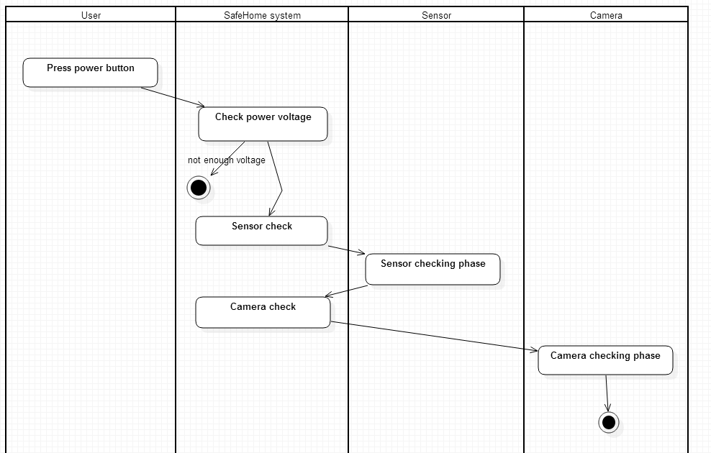

### SafeHome shutdown

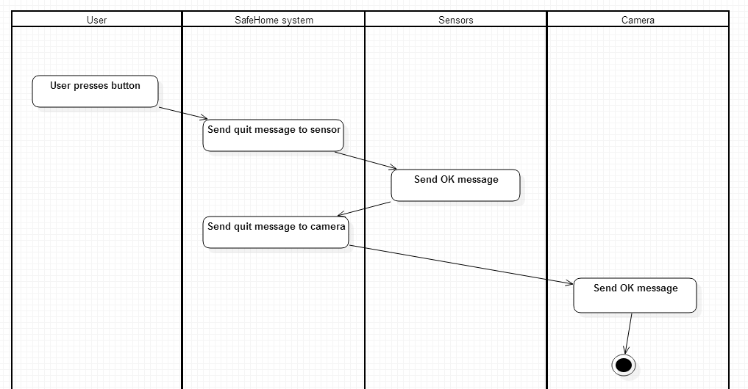

## Configuration service

### Password registration

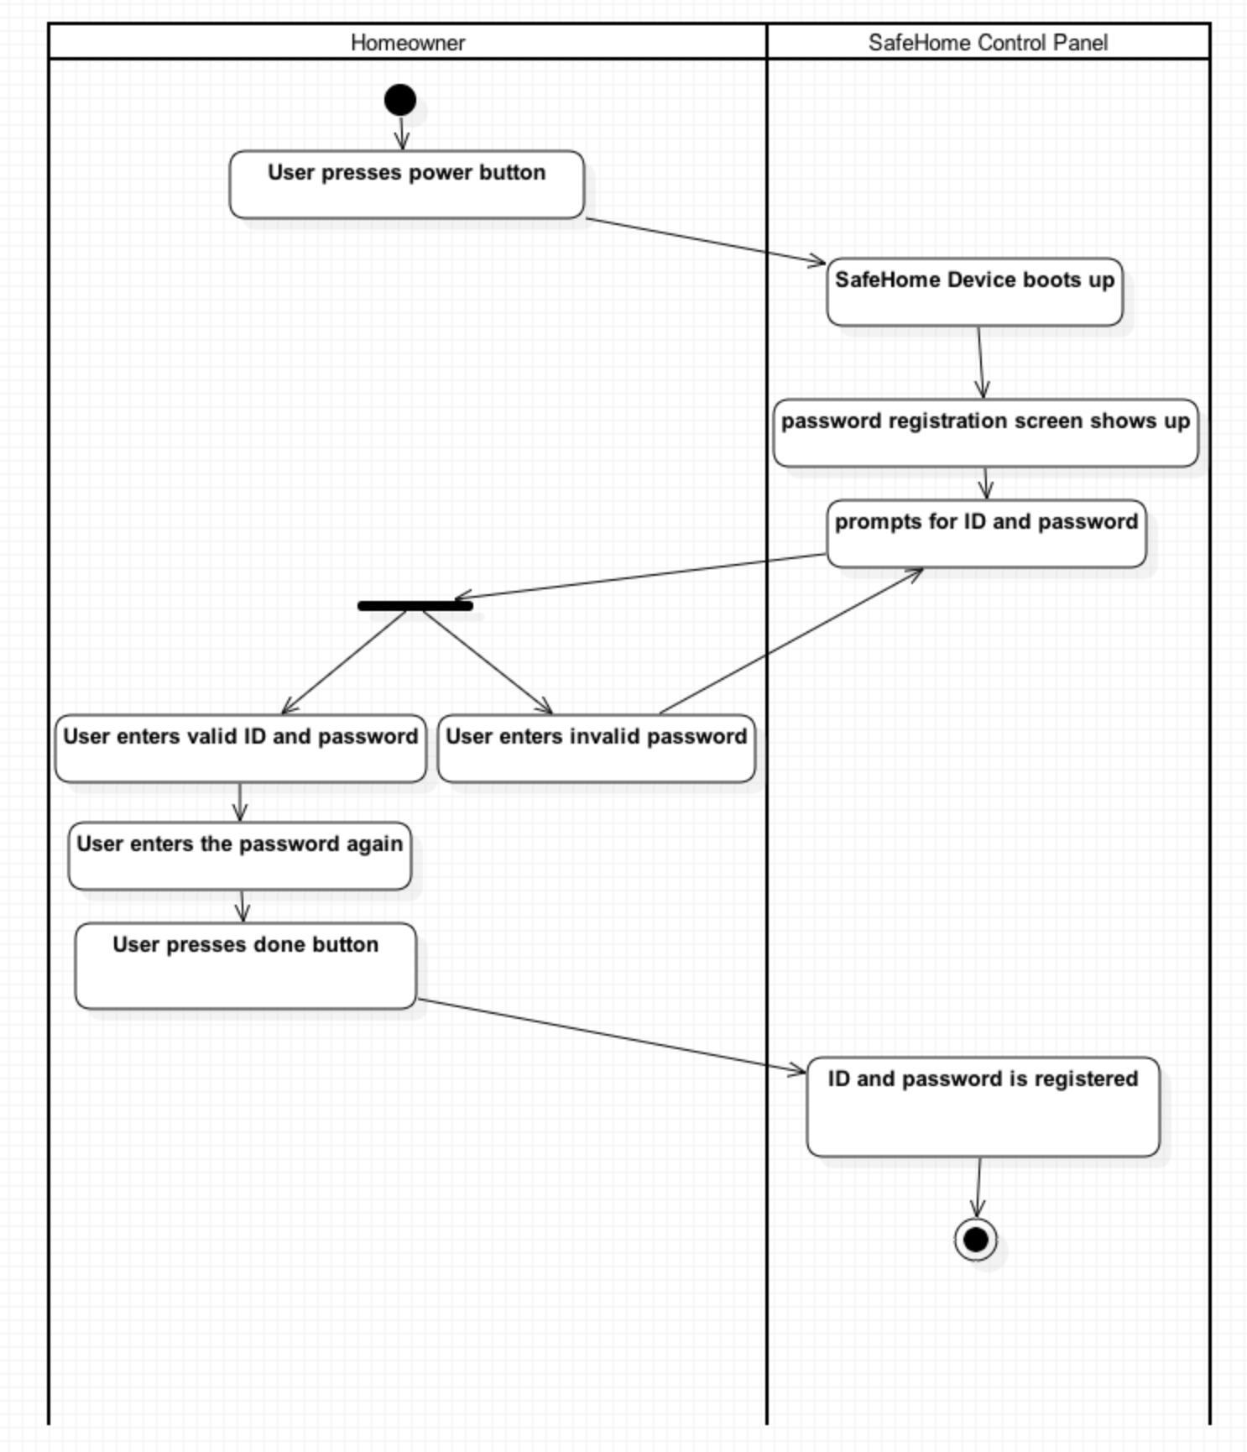

### Password registration (web control panel)

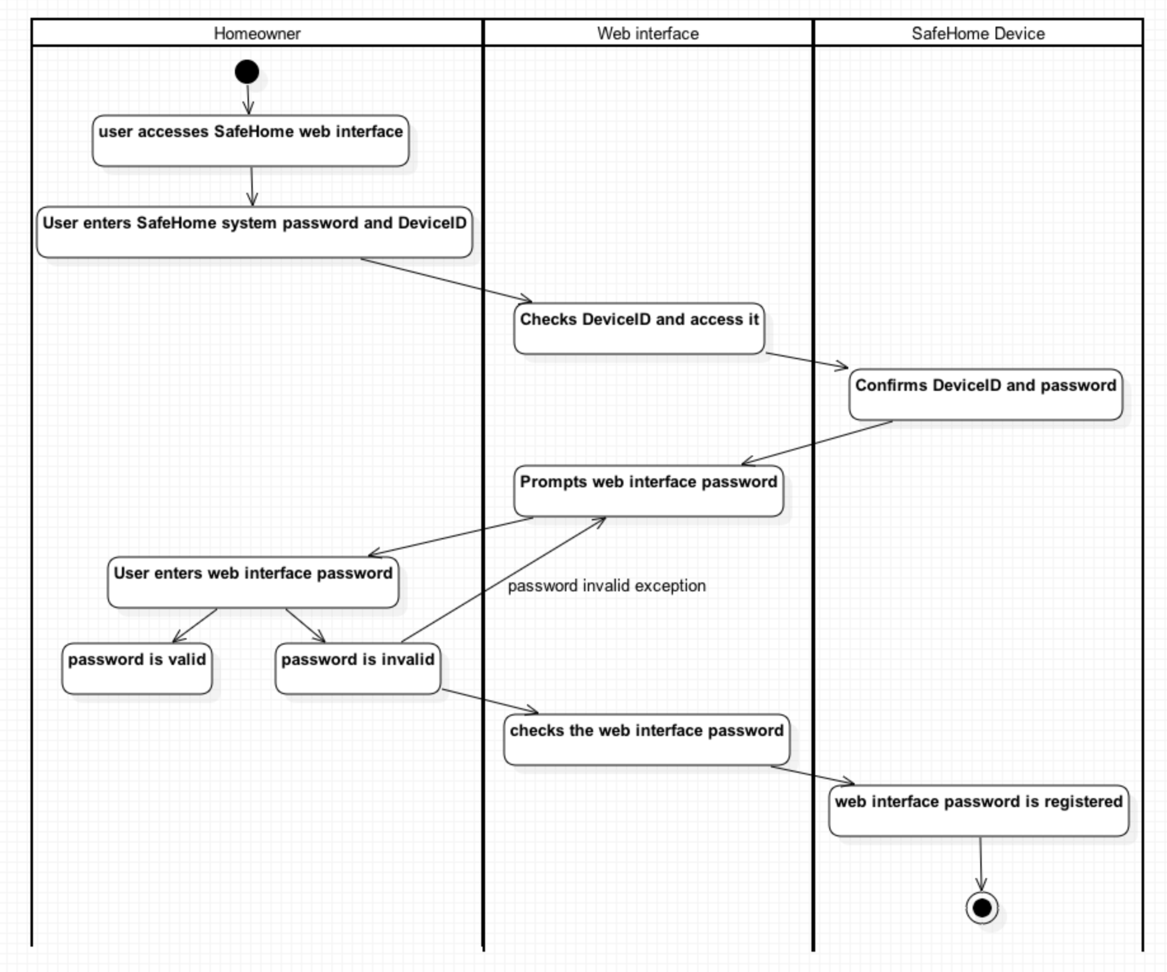

### Grouping devices

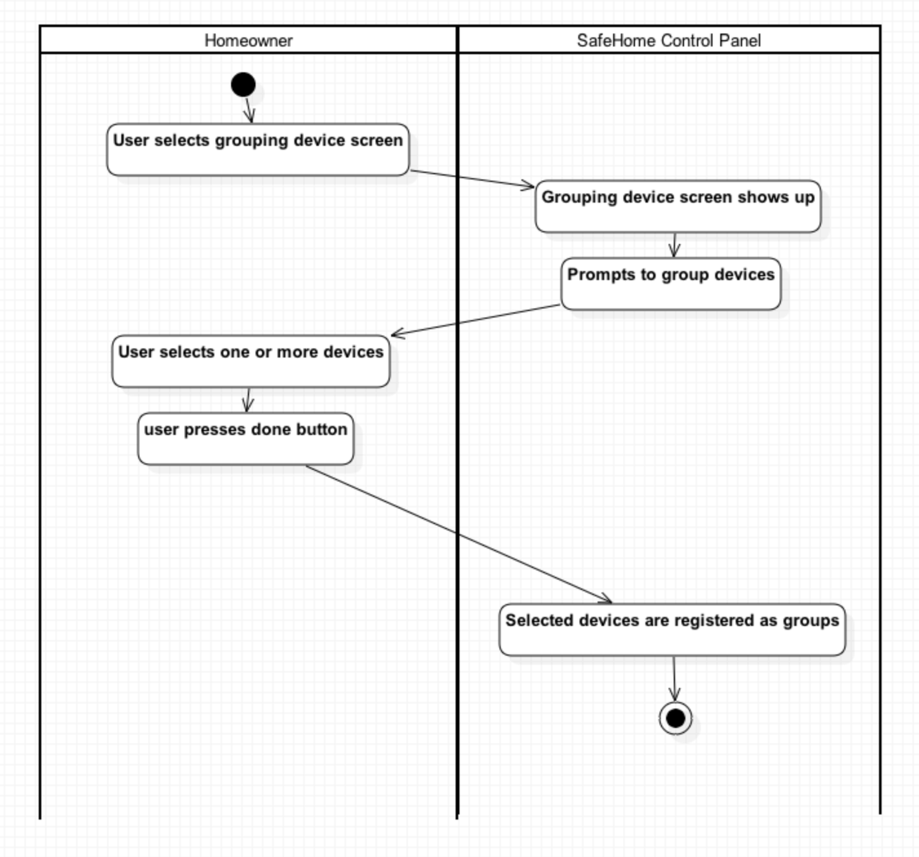

### Web session timeout

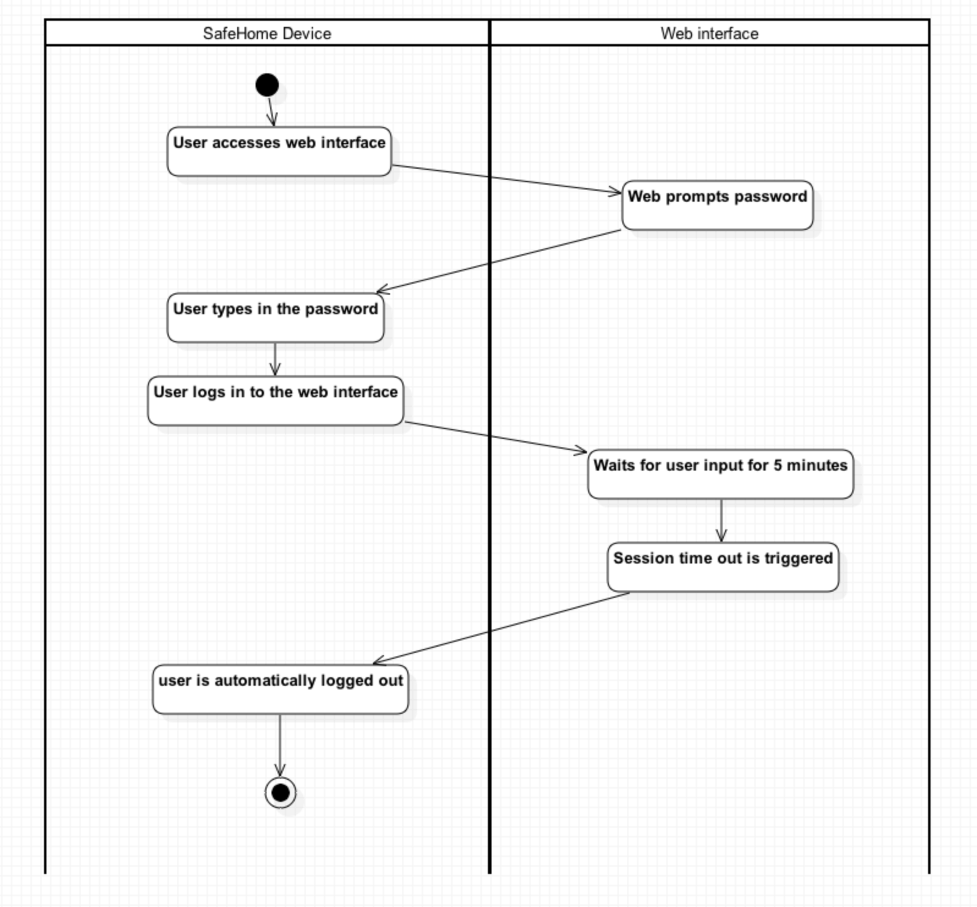

## SafeHome real-time security service

### Arming system

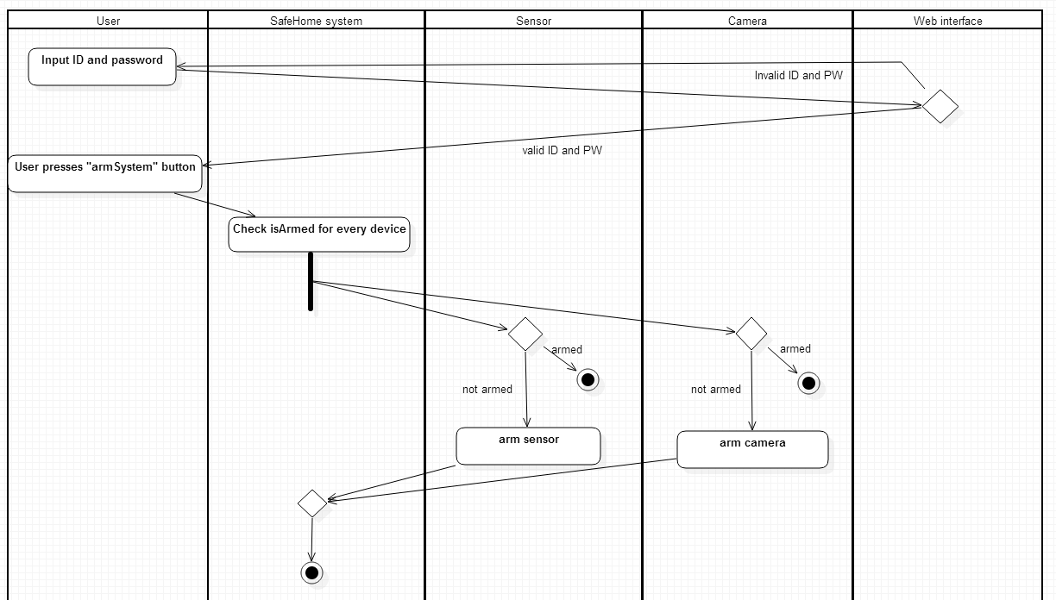

### Arming device

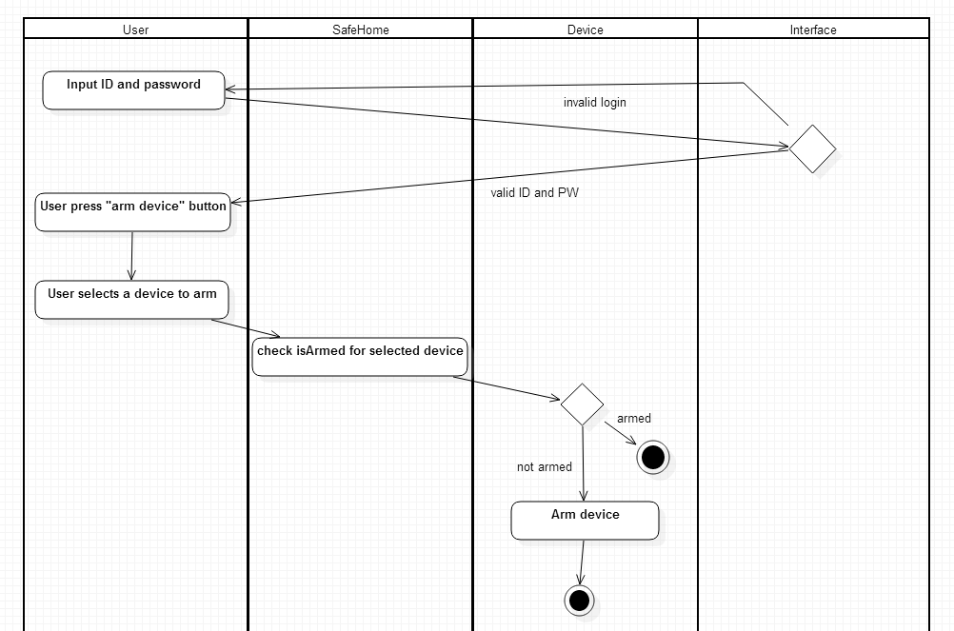

### Disarming system

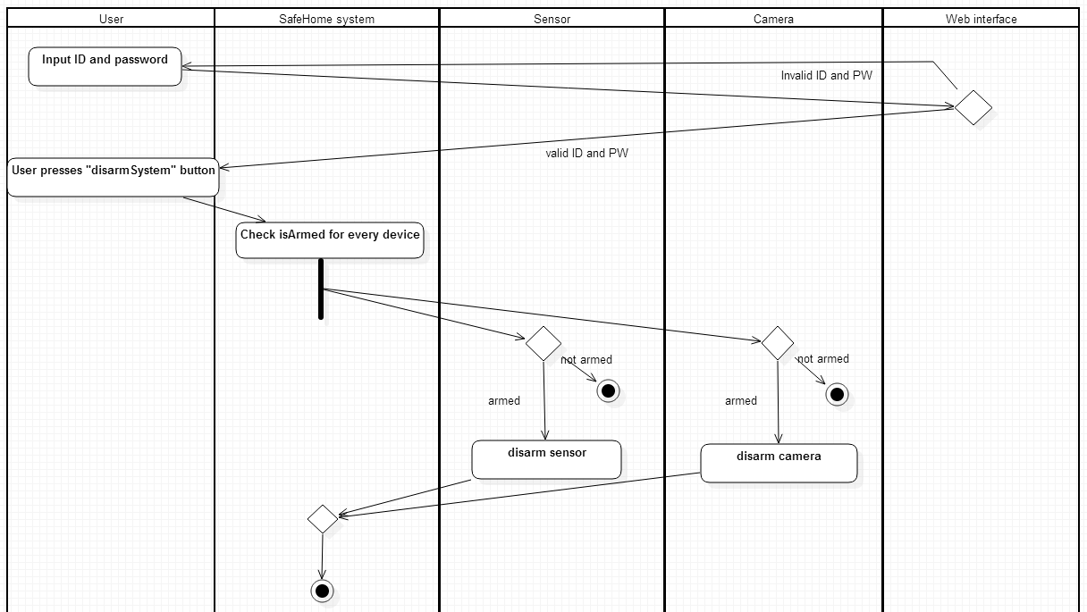

### Disarming device

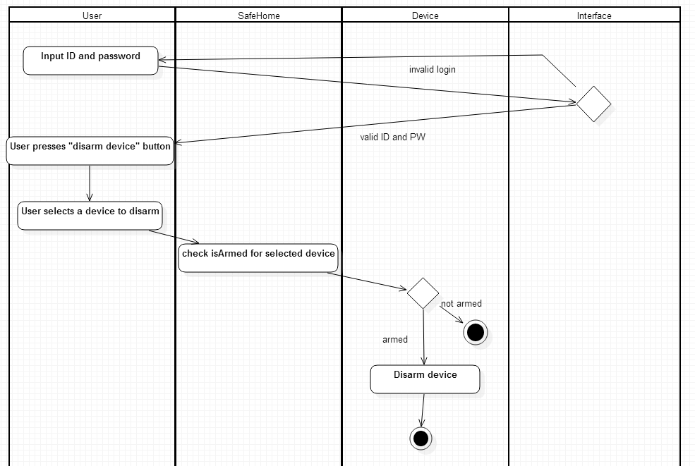

### Set travel mode

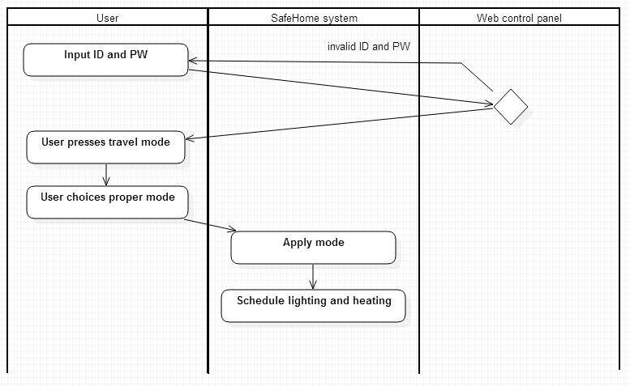

### Detect motion

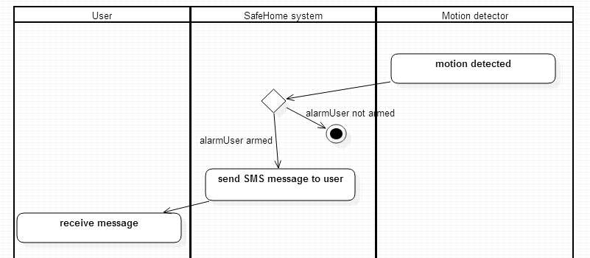

### Detect window action

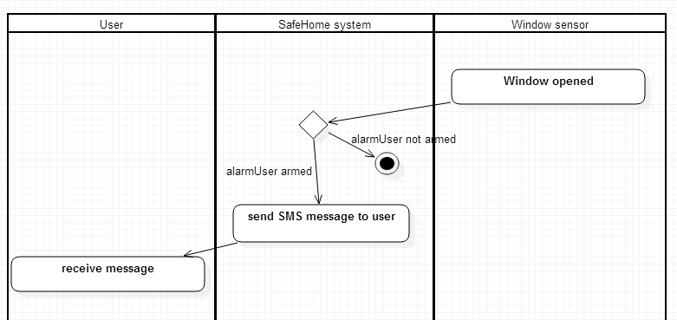

### Detect high gas concentration

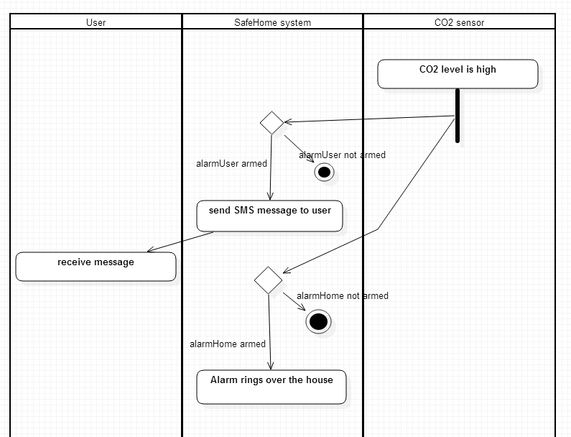

### Fire detection

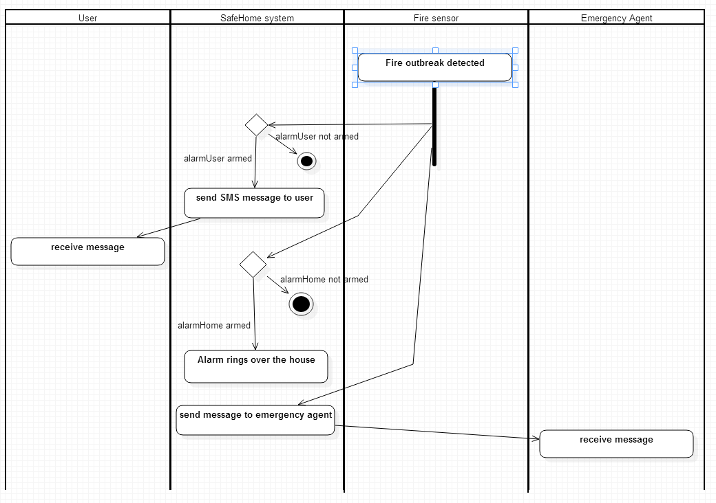

### Detect dog barking

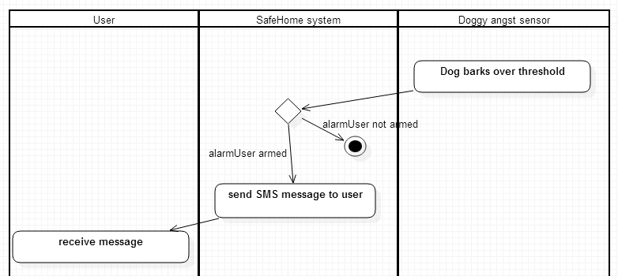

### Camera viewing, zooming, panning

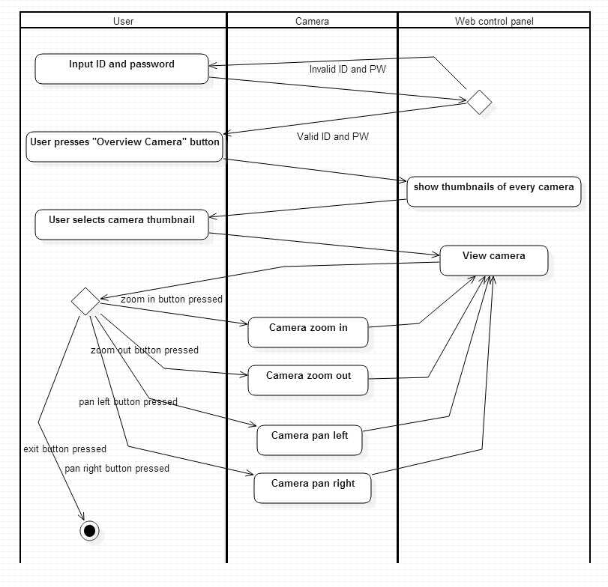

### Retrieve camera data

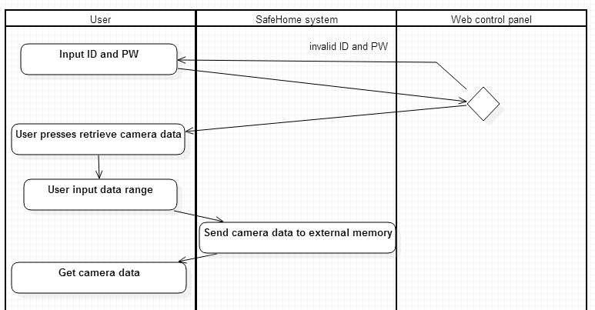

## User-requested information retrieval service

### Find ID and PW

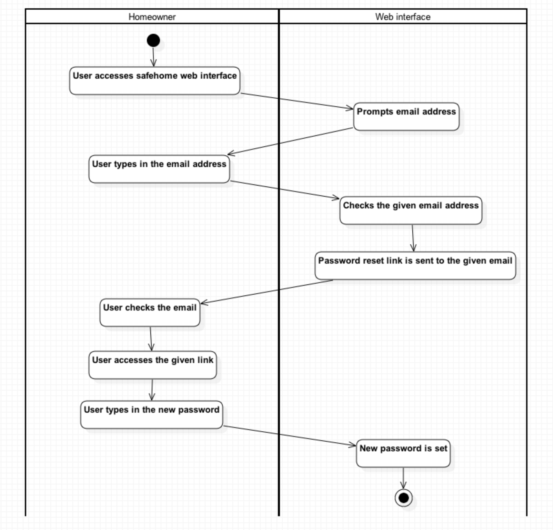

### Report usage pattern

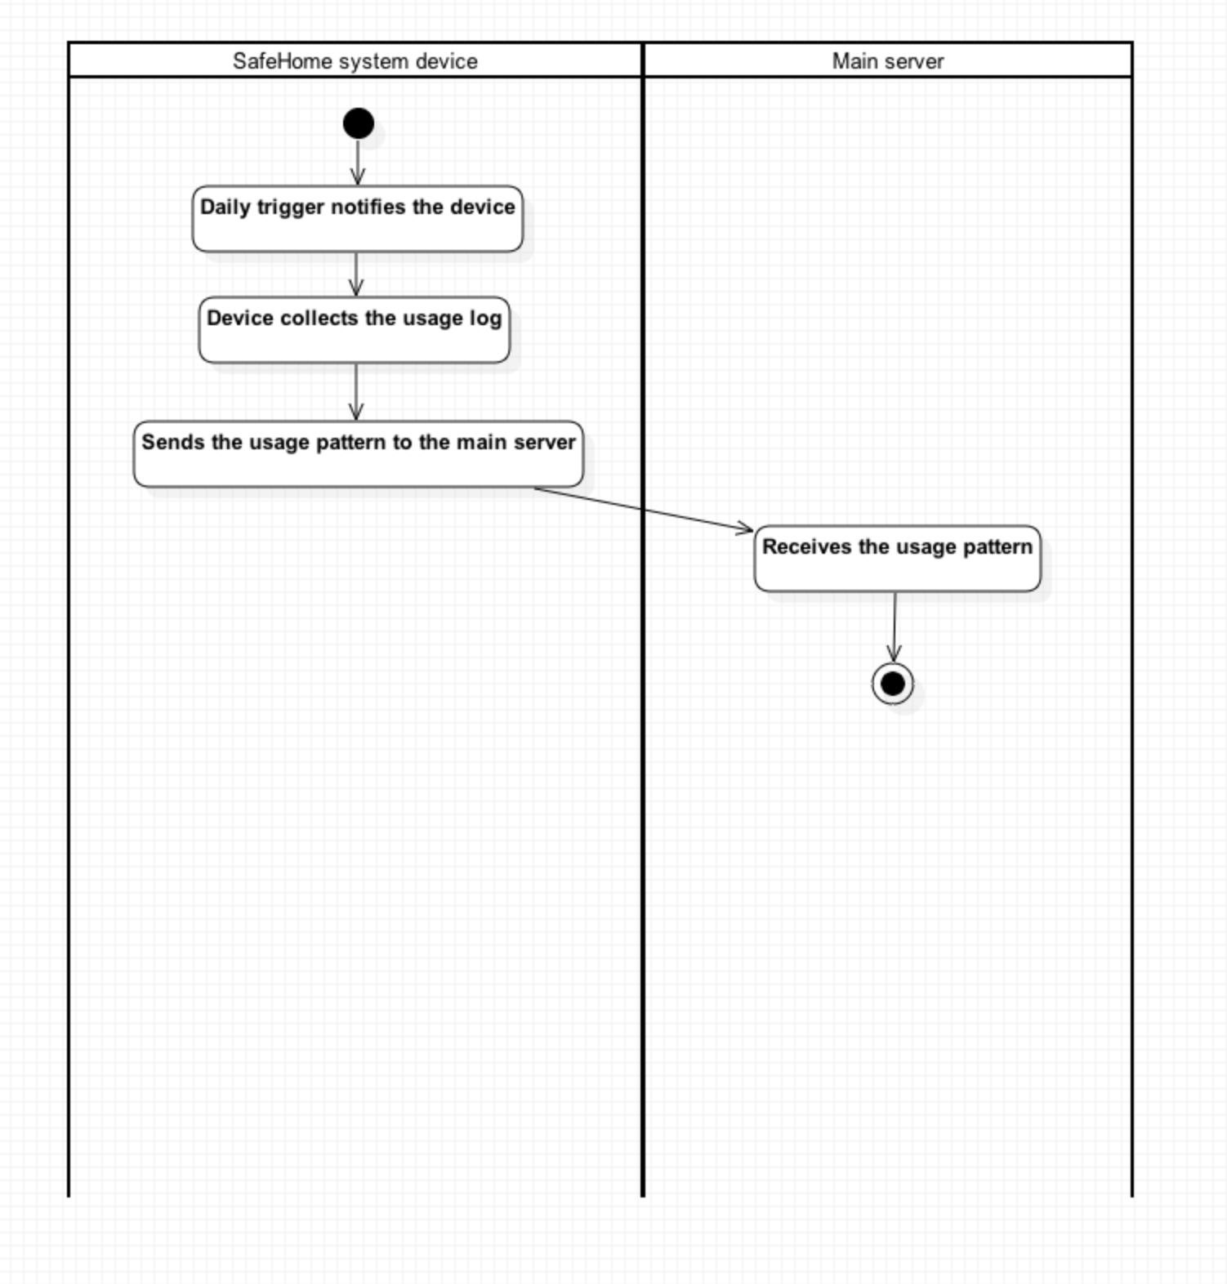

### Report web page access history

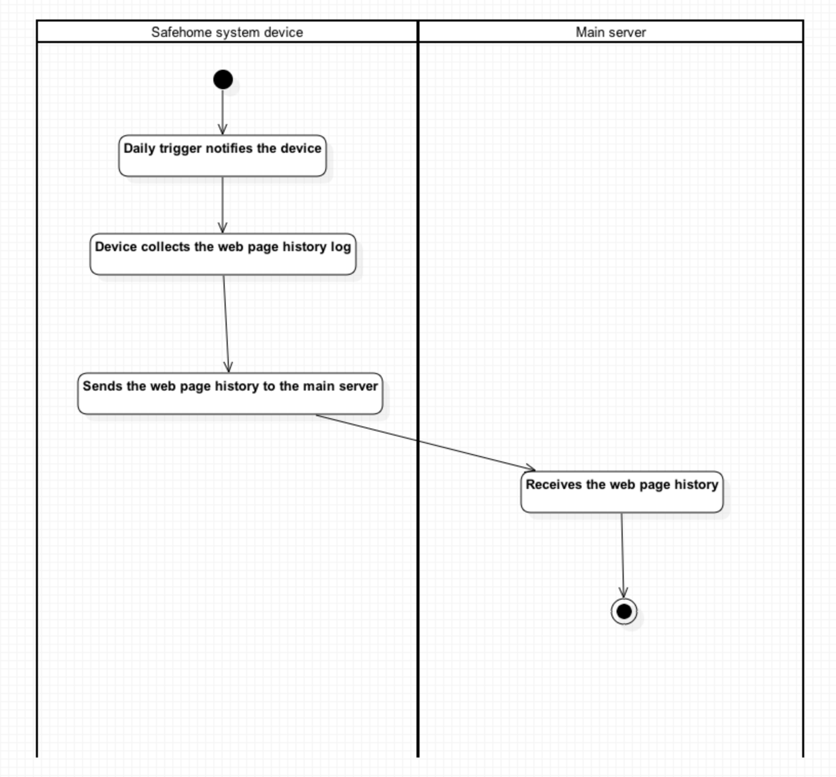

# Authorship

**2 - Use cases**

2.1, 2.3 is written by Seokju Hong

2.2, 2.4 is written by Young Seok Kim

**3 - Use case diagram**

3.1, 3.3 is written by Seokju Hong

3.2, 3.4 is written by Young Seok Kim

**4 - Swimlane diagram**

4.1, 4.3 is written by Seokju Hong

4.2, 4.4 is written by Young Seok Kim

# Feature legends

1. SafeHome bootup/shutdown service
2. SafeHome configuration service
3. SafeHome real-time security service
4. User-requested information retrieval service